**Error Messages from Denticon Perio Voice Command**

Failed to connect with Denticon Voice Command.

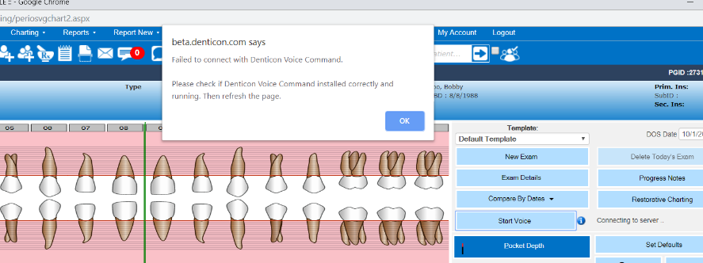

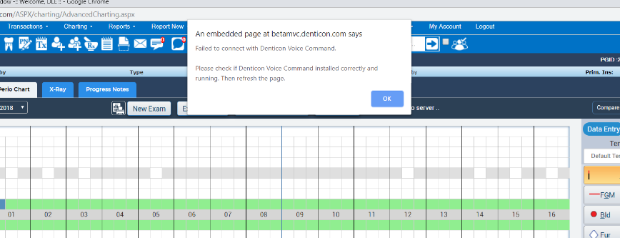

Cannot select “Start”

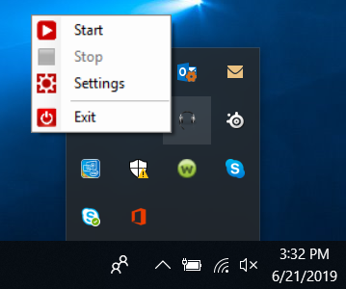

Please follow the instruction below to troubleshoot.

**Troubleshooting Perio Voice**

1. Make sure MSR *.denticon.com and *.planetdds.com are added to Internet Options. For instructions click on the link and scroll down towards **INTERNET EXPLORER**. [Click here.](https://planetdds.zendesk.com/hc/en-us/articles/115002087912-What-are-the-minimum-system-requirements-for-Denticon-to-function-properly-on-my-computer-?source=search&auth_token=eyJ0eXAiOiJKV1QiLCJhbGciOiJIUzI1NiJ9.eyJhY2NvdW50X2lkIjoxOTQ1MTg3LCJ1c2VyX2lkIjozNjkwNzk2NjkzMTIsInRpY2tldF9pZCI6ODAyNzAsImNoYW5uZWxfaWQiOjYzLCJ0eXBlIjoiU0VBUkNIIiwiZXhwIjoxNTYzNzQ2ODI4fQ.IzQ7rcvFtb72LrjYNczk5FXP9LrZ6MwIGfkeli1NvDg)
2. Login to Denticon, go to Setup>Charting>Perio Setup Templates and under Start Voice make sure it is check “Yes”.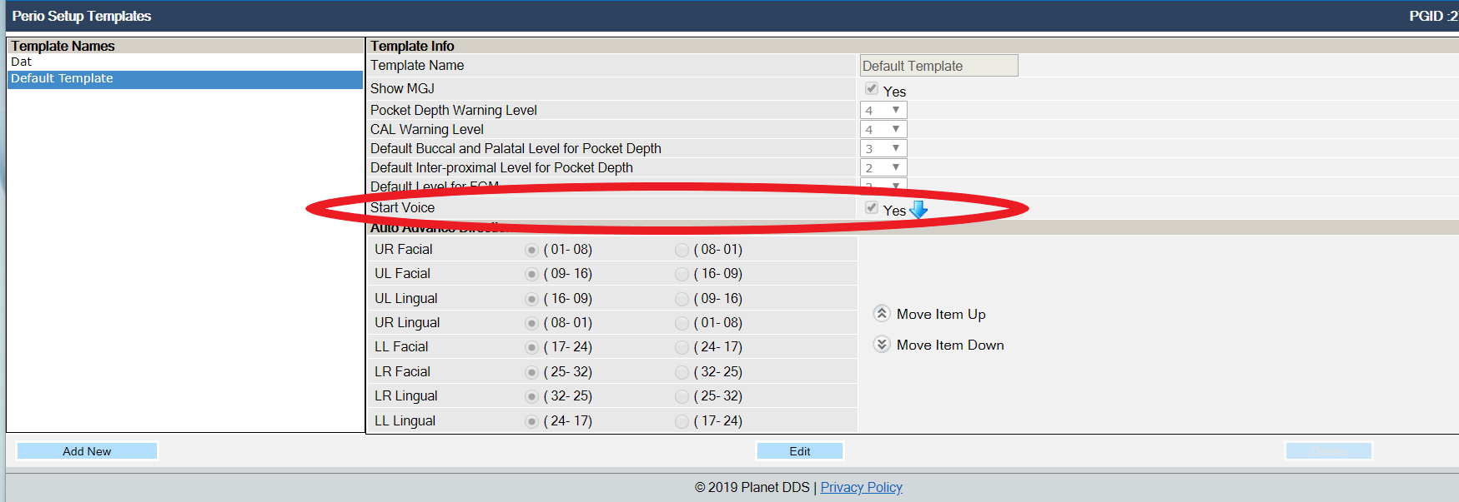
3. Make sure you install the Perio Voice Command from our Denticon Help>Help & Support tab. 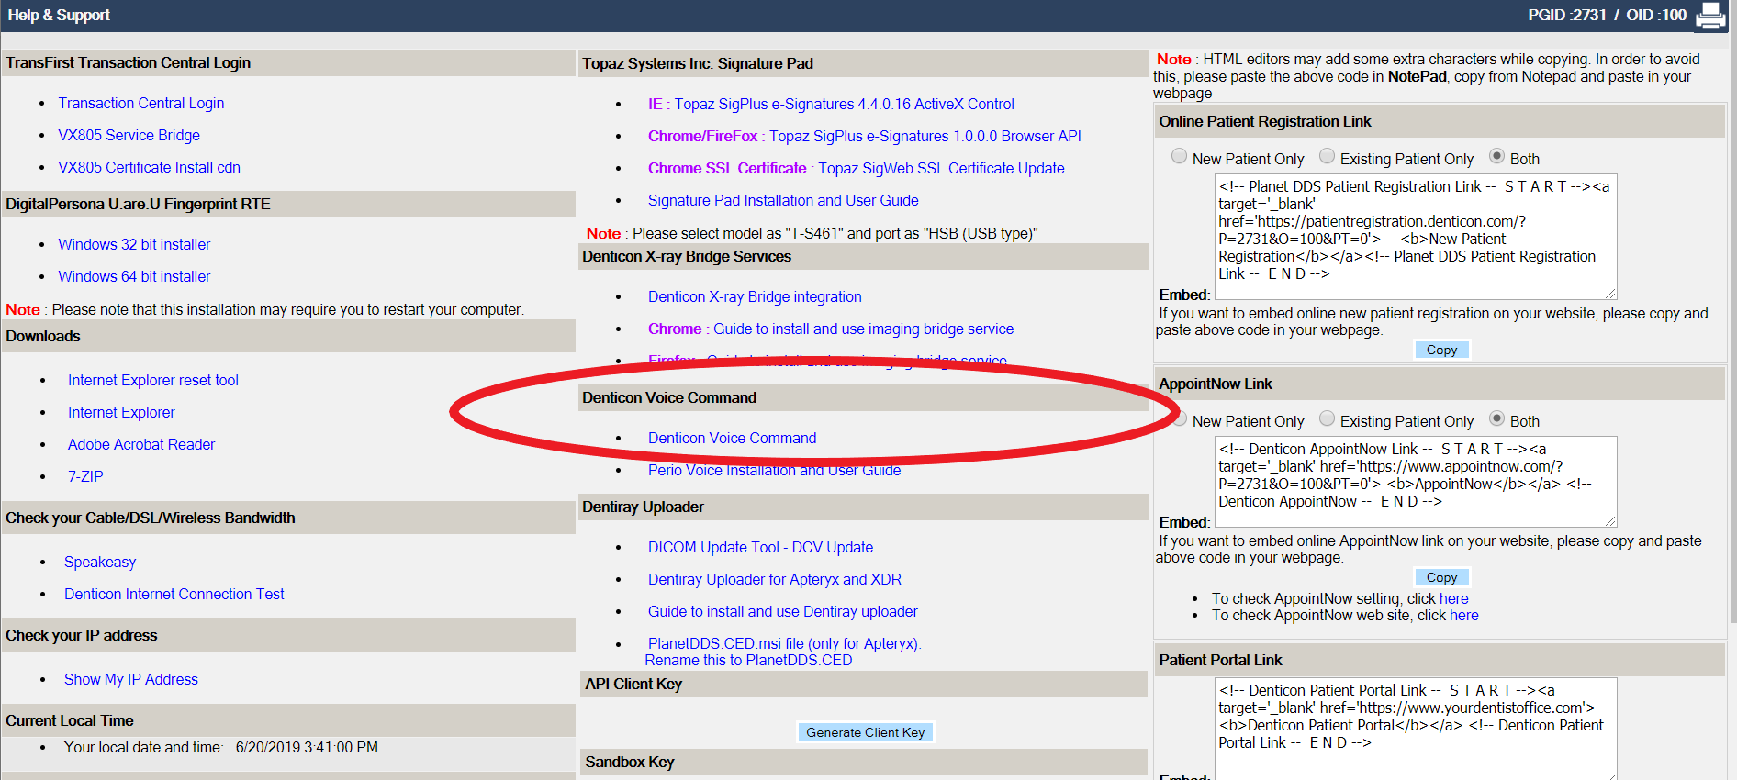
4. Allow Denticon Perio Voice Command through the Firewallby going to Control Panel>Windows Defender Firewall>Select “Allow an app or feature through Windows Defender Firewall”, scroll down to “DenticonVoiceCommandApp” and make sure you have “Private and Public” checked.

